**Energy Efficiency**

For each type we got the energy consumption, fuel efficiency, and carbon emission and we normalised it to 1 by dividing each value by the total. Based on a weighting of 30% for energy consumption, 30% for fuel efficiency, and 40% for the carbon emissions we calculated the weighted energy efficiency for each type.

It is the energy required to transport a bioeconomy product over a given distance. To attain sustainable development objectives, improving energy efficiency reduces greenhouse gas emissions and fuel consumption.

* Energy Consumption (kWh per ton-km): How much energy is needed to transport one ton of goods over one km.
* Fuel Efficiency (L per ton-km): The amount of fuel needed to transport one ton of goods over one km.
* Carbon Emissions (kg of CO2 per ton-km): The quantity of CO2 emitted to transport one ton of product over one km.

Water Transport:

* Energy Consumption: Generally, water transport is more energy efficient. Freezer boats, ferries, and river barges consume less energy compared to other modes.
* Fuel Efficiency: Water transport consumes less fuel per ton-km, so it's more efficient.
* Emissions: Moderate emissions, reflecting efficient energy use.

[ship_emissions_toolkit-g1-online.pdf (imo.org)](https://gmn.imo.org/wp-content/uploads/2018/10/ship_emissions_toolkit-g1-online.pdf)

Road Transport:

* Energy Consumption: Because of the increased friction and energy required to drive on highways, trucks and vans use more energy.
* Fuel Efficiency: Compared to water transportation, trucks and pick-ups use more fuel per ton-km.
* Emissions: Dependent on the type of vehicle, regular trucks and pickups have lower emissions than refrigerated vehicles.

[European Environment Agency's home page (europa.eu)](https://www.eea.europa.eu/en)

Air Transport:

* Energy Consumption: Air transport is less energy-efficient and consumes significant energy per ton-km.
* Fuel Efficiency: Very low, as air transport is fuel intensive.
* Emissions: Very high, especially for helicopters.

[IATA - Environmental Assessment (IEnvA)](https://www.iata.org/en/services/certification/ienva/environmental-assessment/)

[Aviation and the Global Atmosphere — IPCC](https://www.ipcc.ch/report/aviation-and-the-global-atmosphere-2/)

Train Transport:

* Energy Consumption: Energy Consumption: Trains are quite energy efficient, even when transporting bulk goods over long distances.
* Fuel Efficiency: Less efficient than water transportation, but better than road transportation.
* Emissions: Moderate, reflecting efficient fuel use.

[Statistics | UIC - International union of railways](https://uic.org/support-activities/statistics/)

Weighting:

* Energy Consumption Weight: 30%
* Fuel Efficiency Weight: 30%
* Carbon Emissions Weight: 40%

Normalization ensures that each metric is comparable and can be integrated into the formula.

Energy Efficiency = 0.3* Energy Consumption Weight + 0.3* Fuel Efficiency Weight + 0.4* Carbon Emissions Weight

Energy Costs: Electricity Cost: $0.156 per kWh (for households) and $0.125 per kWh (for businesses) as of September 2023 in Brazil​

Fuel Cost: $1.092 per L as of June 2024​

Carbon Emission Cost: Typically, the cost for carbon emissions is around $50 per ton of CO2, which translates to $0.05 per kg of CO2. This is a standard value used in many environmental cost assessments.

[Brazil electricity prices, September 2023 | GlobalPetrolPrices.com](https://www.globalpetrolprices.com/Brazil/electricity_prices/)

[Brazil energy prices | GlobalPetrolPrices.com](https://www.globalpetrolprices.com/Brazil/)

[The true cost of carbon pollution (edf.org)](https://www.edf.org/true-cost-carbon-pollution)

**Digital Access**

Depending on the factory locations, if it is located in a rural unconnected area the improvement of digital access will be more valuable than if it is located in an urban connected area.

The improvement will be assessed incrementally with a factor of 0.2. If the facility is built in a town without connection the factor will be 1 going down to 0.8 if the town has 2G connection, 0.6 if the town has 3G, 0.4 if the town has 4G, 0.2 if the town has 4G+, to 0 if the town has 5G

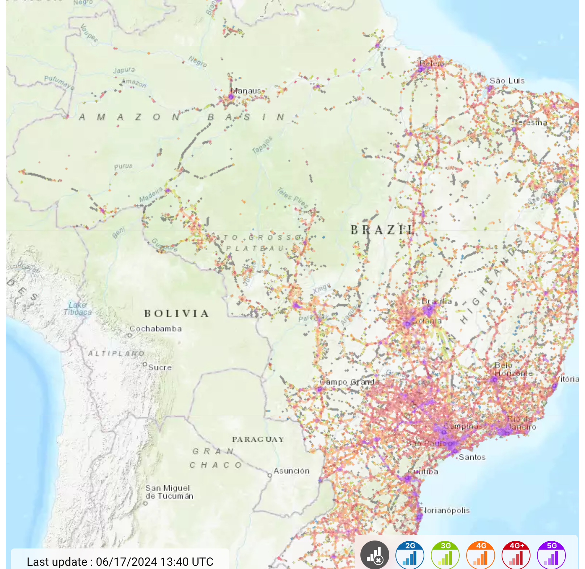

The extent and quality of digital connection required for efficient coordination, monitoring and optimisation of transport operations in Logistics supply chain management is referred to as digital access. Improved digital access helps in enhancing logistical efficiency, reduces operational costs, and supports economic growth.

* Network Coverage (% of area): The percentage of the Amazon region covered by digital networks (2G/3G/4G/5G).

[3G / 4G / 5G coverage in Brazil - nPerf.com](https://www.nperf.com/en/map/BR/-/161704.Vivo-Mobile/signal?ll=-7.079088026071719&lg=-57.64526367187501&zoom=6)

Min: 20% (representing very remote areas with little to no coverage)

Max: 95% (representing urban areas with almost full coverage)

* Internet Penetration Rate (% of population): The percentage of the population with internet access.

[Brazil: internet user penetration 2029 | Statista](https://www.statista.com/forecasts/292757/brazil-internet-user-penetration#:~:text=It%20was%20forecast%20that%2C%20in%202023%2C%20around%2081.79,the%20Brazilian%20population%20would%20have%20accessed%20the%20web.)

[Brazil internet usage reach by urbanity 2023 | Statista](https://www.statista.com/statistics/1347531/internet-usage-reach-urbanity-brazil/)

[Individuals using the Internet (% of population) - Brazil | Data (worldbank.org)](https://data.worldbank.org/indicator/IT.NET.USER.ZS?end=2022&locations=BR&start=1990)

[Legal Amazon population in Brazil 1970-2021 | Statista](https://www.statista.com/statistics/1251314/amazon-population-brazil/)

[Population, total - Brazil | Data (worldbank.org)](https://data.worldbank.org/indicator/SP.POP.TOTL?end=2022&locations=BR&start=1960&view=chart)

[Amazonas (Brazilian state) - Wikipedia](https://en.wikipedia.org/wiki/Amazonas_%28Brazilian_state%29)

Total population in Brazil in 2022: 215 million

Resident population in the rural area in 2022: 3.94 million

Internet usage penetration in rural areas in 2022: 72% (2.9 million have internet access)

Internet usage penetration in urban areas in 2022: 82%

Min: 72% (very low penetration in remote areas)

Max: 82% (high penetration in urban areas)

* Data Transfer Speed (Mbps): The average speed of data transfer in the region.

[Brazil: mobile broadband internet speed 2022 | Statista](https://www.statista.com/statistics/1135124/brazil-internet-speed/) ???

Min: 10 Mbps (low speed in remote areas)

Max: 60 Mbps (high speed in urban areas)

Weighting:

* Network Coverage Weight: 35%
* Internet Penetration Rate Weight: 35%
* Data Transfer Speed Weight: 30%

Digital access weighting = 0.35* Network Coverage Weight + 0.35* Internet Penetration Rate Weight + 0.3* Data Transfer Speed Weight